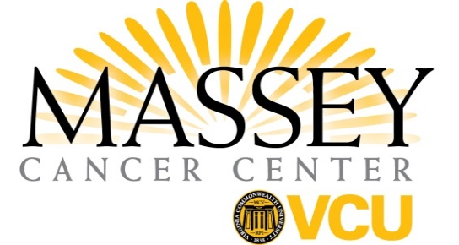
Letter of Intent
Funding Mechanism
____ American Cancer Society Institutional Research Grant (ACS IRG)
____ Innovation Pilot Award
____ Team Science Pilot Award*
____ Novel Agent Pilot Award
____ Statewide Collaboration Award
____ NCI Catalyst Award

Project Title:

Investigator Information
Investigator(s) name(s):
Role in project:

Key collaborators and their roles:
Name(s):

All applicants are required to consult a biostatistician as part of the application process. Please contact the Biostatistics Shared Resource to make an appointment. Applicants are also strongly encouraged to incorporate a community champion in the development of the proposal. To consult with a potential champion, please contact cancerchamps@vcu.edu.
Specific Aims
What are the specific Aims of the project?

Project Description
Provide a brief project description.
*If a team science proposal provide specific aims and brief description for each project/core.

